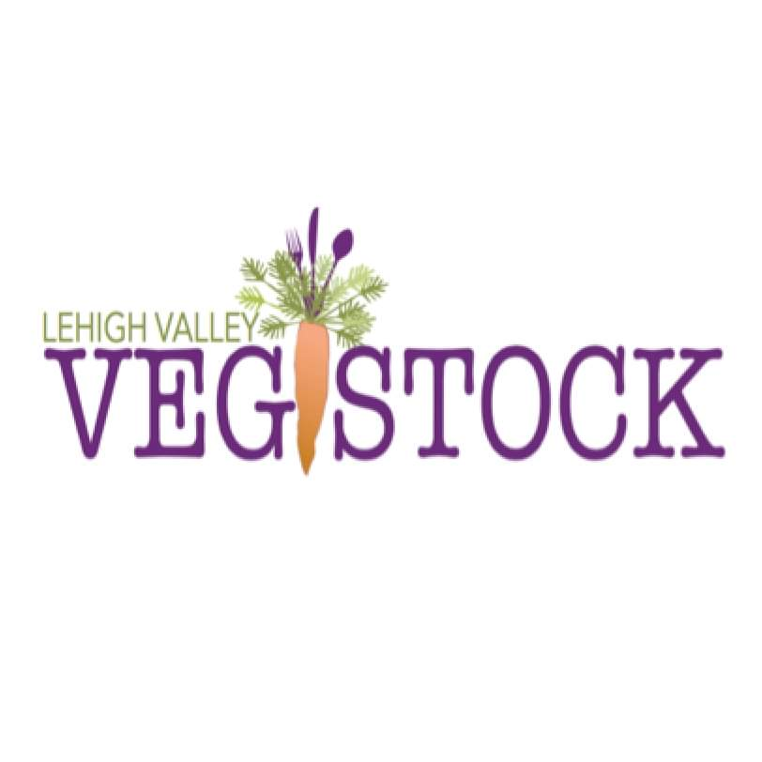

**October 12th, 2019**

**SPONSORSHIP 2019**

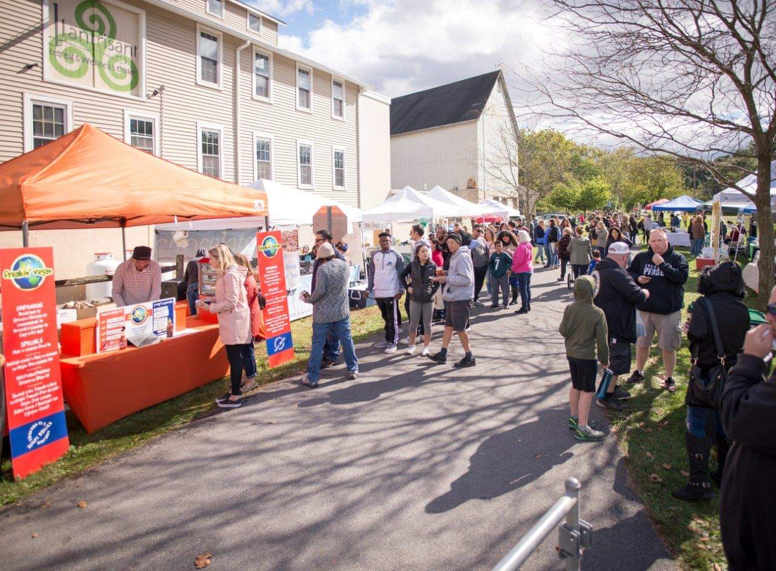

**EIN #: 26-2623498**

**Lehigh Valley VegStock will be held on**

**Saturday, October 12th from 11:00 AM-5:00 PM at**

**Llanstrisant Retreat and Wellness Center in Tatamy,**

**PA. This healthy harvest festival will bring together**

**vendors, crafters, live music and entertainment, and activities for all ages. The event will highlight food that delights your taste buds while nourishing your body, and guest speakers discussing tips to live your**

**healthiest and most vibrant life!**

**~~~~~~~~~~~~~~~~~~~~~~~~~~~~~~~~~**

***ALL PROCEEDS from the event will benefit***

***Kellyn Schools Healthy Lifestyle presentations and***

***"Garden as a Classroom" programs in 39 local elementary schools, as well as Kellyn Food Access programs like the Eat Real Food Mobile Market.***

**PRESENTING SPONSOR: $5,000**

* Marketing materials placed on registration table (provided by sponsor prior to event)
* Logo printed on t-shirts that will be sold at Lehigh Valley VegStock
* Acknowledgement of sponsorship on Facebook event page AND Kellyn’s Facebook page, announcing you as our Presenting Sponsor
* Free Vendor Spot (Must fall within our vendor guidelines for the event)
* Your banner displayed on the day of the Lehigh Valley VegStock (provided by sponsor prior to event)
* Announcement over loud speaker with your business name and thanking you for your support/sponsorship 3 times over the course of the event
* $50 certificate to be used for our Lifestyle Medicine meals during the 2019 or 2020 season
* Kellyn newsletter sent out mentioning your business as our presenting sponsor
* $50 certificate to be used on the Kellyn Mobile Market for produce during the 2020 season
* Your name/business name displayed next to registration table at Lehigh Valley VegStock on a poster board, labeled as the “Presenting Sponsor”
* Marketing materials placed on registration table (provided by sponsor prior to event)
* Logo printed on t-shirts that will be sold at Lehigh Valley VegStock
* Acknowledgement of sponsorship on the Facebook event page
* Free Vendor Spot (Must fall within our vendor guidelines for the event)
* Your banner displayed on the day of the Lehigh Valley VegStock (provided by sponsor prior to event)

**SPROUT SPONSORSHIP: $1,000**

* Marketing materials placed on registration table (provided by sponsor prior to event)
* Logo printed on t-shirts that will be sold at Lehigh Valley VegStock
* Acknowledgement of sponsorship on Facebook event page
* Free Vendor Spot (Must fall within our vendor guidelines for the event)
* Your banner displayed on the day of the Lehigh Valley VegStock (provided by sponsor prior to event)
* Announcement over loud speaker with your business name and thanking you for your support/sponsorship 3 times over the course of the event
* $50 certificate to be used for our Lifestyle Medicine meals during the 2019 or 2020 season

**SEED SPONSORSHIP: $2,500**

**PLANT SPONSORSHIP: $500**

* Marketing materials placed on registration table (provided by sponsor prior to event)
* Logo printed on t-shirts that will be sold at Lehigh Valley VegStock
* Acknowledgement of sponsorship on the Facebook event page
* Free Vendor Spot (Must fall within our vendor guidelines for the event)
* Your banner displayed on the day of the Lehigh Valley VegStock (provided by sponsor prior to event)
* A sign placed at the t-shirt sales area thanking you for being our t-shirt sponsor
* Marketing materials placed on registration table (provided by sponsor prior to event)
* Logo printed on t-shirts that will be sold at Lehigh Valley VegStock
* Acknowledgement of sponsorship on the Facebook event page
* Free Vendor Spot (Must fall within our vendor guidelines for the event)
* Your banner displayed on the day of the Lehigh Valley VegStock (provided by sponsor prior to event)
* A sign placed at the music area thanking you for being our music sponsor
* Marketing materials placed on registration table (provided by sponsor prior to event)
* Logo printed on t-shirts that will be sold at Lehigh Valley VegStock
* Acknowledgement of sponsorship on the Facebook event page
* Free Vendor Spot (Must fall within our vendor guidelines for the event)
* Your banner displayed on the day of the Lehigh Valley VegStock (provided by sponsor prior to event)
* A sign placed at the kids activity area thanking you for being our activity sponsor
* Announcement as our speaker/activity sponsor during the presentations throughout the day

**T-SHIRT SPONSOR: $1,500**

**MUSIC SPONSORSHIP: $1,500**

**SPEAKER/ACTIVITY SPONSORSHIP: $2,000**

* Marketing materials placed on registration table (provided by sponsor prior to event)
* Logo printed on t-shirts that will be sold at Lehigh Valley VegStock
* Acknowledgement of sponsorship on the Facebook event page

**Contribution Level**

* **Presenting - $5,000**
* **Seed - $2,500**
* **Sprout - $1,000**
* **Plant - $ 500**
* **Speaker/Activity - $2,000**
* **Music - $1,500**
* **T-Shirt - $1,000**
* **Other - ______**

**\*Please Circle Level of Sponsorship**

**Company Name: ____________________________**

**Contact Name: _____________________________**

**Address: __________________________________**

**__________________________________**

**Phone: ___________________________________**

**Email: ____________________________________**

**Mail Form/Make Checks Payable To:**

**Kellyn Foundation**

**P.O. Box 369**

**336 Bushkill Street**

**Tatamy, PA 18085**

**Questions? Contact Amanda Grega:**

**610-730-8860**